**How to run segments in Latent Gold,**

**particularly for Consumer Research, e.g. Product/Concept Fit tests**

Here’s some screenshots for setting up the clustering process.

Move the products over. Make sure they are continuous, not ord-fixed (default) by right clicking and changing it to continuous.

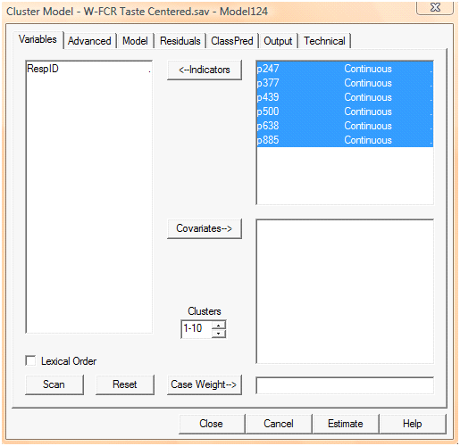

Technical – increase the number of iterations to be more robust.

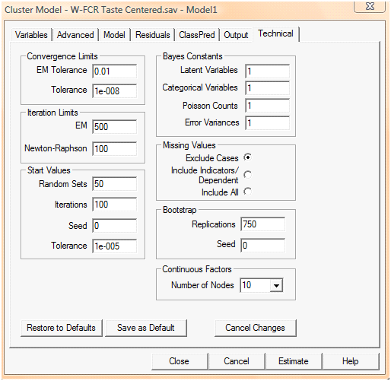

When you know the cluster size you want to go with, add the id’s into the ‘standard classification’ so you know which person is in which cluster (It won’t let you do this if you are trying to iterate 1-10 clusters. Have to define exact cluster size):

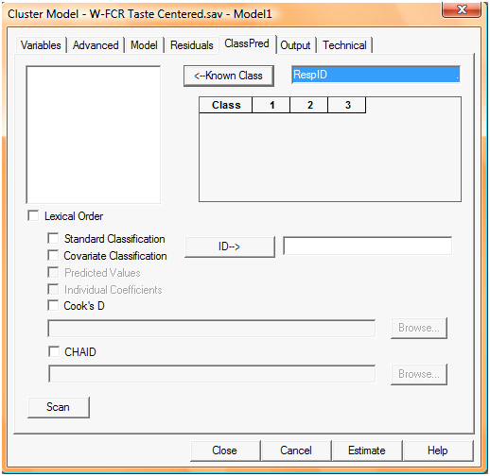

After you run, go back in and make sure that all the boxes for the classes are checked…

